

**University Of Barishal**

**ASSAIGNMENT**

**Crouse Tittle: Information And Communication Technology**

**Crouse Code: 0611 HIS 114**

**Assaignment Tittle**:Maynamati: The Cradle of Ancient Buddhist Heritage In Bengal

**Subbmited To:**

MD.Erfan Sir

Assistant Professor And Chairman

Computer Science And Enginnering

**Submitted By:**

1. Jippu Roy Chomok 3.Tamanna Tasmia

Roll:230504033 Roll:230504020

2.Mafuzur Rahman Kawsar 4.Shofiqul Islam

Roll:230504037 Roll:230504031

**Session: 2022-2023**

**Department: History**

**Submitted Date: 08.10.2024**

**Maynamati: The Cradle of Ancient Buddhist Heritage in Bengal**

**Maynamati** is an important historical and archaeological site in the Cumilla district of Bangladesh, known for its extensive ruins of ancient Buddhist monasteries, temples, and other structures dating back to the early medieval period. The site, located in the **Mainamati-Lalmai** hill range, is one of the most significant centers of Buddhist heritage in Bangladesh and played a crucial role in the region’s religious and cultural history.

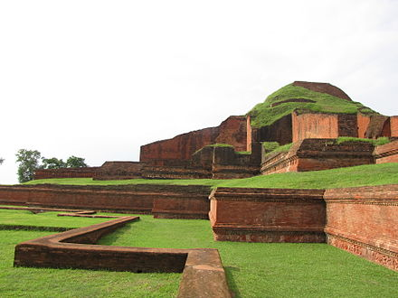

Picture:Maynamati

**Historical Background:**

* **Ancient Buddhist Center:** Maynamati, along with its sister site Lalmai, was a thriving center of Buddhism between the 7th and 12th centuries, during the rule of the **Pala Dynasty** and later the **Deva Dynasty**. These dynasties were strong supporters of Mahayana Buddhism, and under their patronage, many monasteries (viharas), stupas, and temples were built in the area.
* **Educational Hub:** The monasteries at Maynamati were not only spiritual centers but also institutions of higher learning, where monks and scholars studied Buddhist philosophy, scriptures, and art.

**Key Archaeological Sites in Maynamati:**

1. **Shalban Vihara:** One of the most well-preserved and important sites in Maynamati, Shalban Vihara is a large Buddhist monastery complex with 115 monk cells surrounding a central courtyard, where the main temple stood. The vihara was a significant center for both monastic life and Buddhist education.
2. **Ananda Vihara:** Another large monastery complex located near Shalban Vihara, Ananda Vihara was a similar educational and religious center for Buddhist monks. Its ruins include cells for monks, temples, and stupas, with many important artifacts discovered during excavations.
3. **Bhoj Vihara:** This site contains the ruins of a smaller Buddhist monastery and is part of the greater Maynamati-Lalmai archaeological zone. It highlights the extensive network of religious sites in the region.
4. **Rupban Mura:** This is a Buddhist stupa complex that was used as a shrine or religious site. The ruins here include stupas and temples, where sacred relics were once enshrined.
5. **Itakhola Mura:** Another archaeological site in the Maynamati area, Itakhola Mura is a Buddhist temple complex consisting of three stupas and a central shrine. It offers insights into the religious practices of the time.

**Mainamati Museum:**

* The **Mainamati Museum** is located near the Shalban Vihara site and serves as a repository for many of the artifacts excavated from the area. It houses terracotta plaques, stone sculptures, bronze statues of Buddha, pottery, coins, and inscriptions that reflect the artistic, cultural, and religious heritage of Maynamati.
* The museum is a key destination for visitors to the area and provides a deeper understanding of the region’s Buddhist past.

**Cultural and Religious Importance:**

* **Buddhist Heritage:** Maynamati was a key center for the spread of Mahayana Buddhism in Bengal. The monasteries here were connected to other significant Buddhist sites in South Asia, such as **Nalanda** and **Vikramashila** in India. The influence of these monastic institutions extended throughout the region.
* **Architecture and Art:** The architecture of the monasteries and temples in Maynamati reflects the religious and cultural synthesis of the period. The terracotta plaques, sculptures, and stupas found at these sites are some of the finest examples of Buddhist art in ancient Bengal.

**Preservation and Tourism:**

* **Archaeological Conservation:** The Bangladesh Department of Archaeology has taken steps to preserve the ruins at Maynamati. Excavations have revealed numerous artifacts, many of which are now on display in the Mainamati Museum.
* **Tourist Attraction:** Today, Maynamati is a popular destination for history enthusiasts, archaeologists, and tourists interested in ancient Buddhist sites. Visitors can explore the ruins of monasteries, stupas, and temples, and learn about the rich history of the region through the artifacts displayed in the museum.

**Modern Context:**

* **Military Cantonment:** A part of Maynamati is also home to a military cantonment, which was established during the British colonial period and continues to be an important military area in modern Bangladesh.

**Connection to Lalmai Hills:**

* The **Mainamati-Lalmai** range stretches over 18 kilometers, with Maynamati representing the northern section of the range. The southern section, Lalmai, also contains archaeological sites and is equally important in understanding the region’s ancient Buddhist culture.

**Here are some Details About Vihara:**

**Shalban Vihara**

**Shalban Vihara** is an ancient Buddhist monastery located in the Maynamati region near Cumilla, Bangladesh. It is one of the most prominent archaeological sites in the country and is part of the larger **Mainamati-Lalmai** archaeological complex, which is known for its Buddhist heritage. Shalban Vihara offers deep insights into the religious, cultural, and educational life of ancient Bengal during the early medieval period.

**Historical Background:**

* **Time Period:** Shalban Vihara was constructed between the 7th and 12th centuries AD during the rule of the **Pala Dynasty**, a time when Buddhism was the dominant religion in Bengal. The monastery flourished as a center for Buddhist learning and meditation.
* **Purpose:** It served as a residential monastery for monks and scholars. The vihara functioned as a spiritual and educational center where monks studied Buddhist philosophy, practiced meditation, and lived communally.
* **Excavation:** The ruins of Shalban Vihara were first excavated in the early 20th century by archaeologists. These excavations revealed a well-preserved monastery complex with various religious and residential structures.

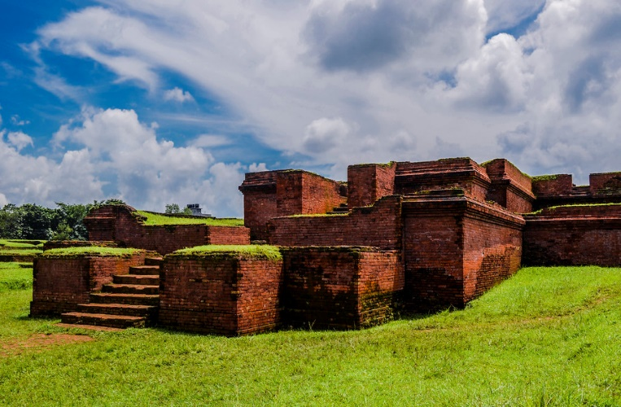

Picture: Shalban Vihara

**Architectural Features:**

Shalban Vihara follows the typical architectural style of early medieval Buddhist monasteries, with a focus on religious, residential, and educational functions.

1. **Monastery Layout:**
   * The vihara is designed as a large rectangular complex measuring approximately **168 square meters**.
   * The monastery consists of **115 monk cells**, arranged in four rows around a central courtyard. Each cell was used as a living quarter for the monks.
   * The entire monastery complex is enclosed by a solid brick wall, which provided both security and privacy for the residents.
2. **Central Shrine:**
   * In the middle of the courtyard stands the main **central shrine**, which was likely the most important structure in the monastery. The shrine was used for religious rituals, meditation, and prayer.
   * The central temple housed a large statue of **Gautama Buddha**, which would have been the focal point of worship for the monks.
3. **Stupas:**
   * Numerous smaller **stupas** and votive stupas are found scattered around the vihara. Stupas were built as religious monuments and were often used to house sacred relics associated with Buddha or other significant Buddhist figures.
4. **Terracotta Plaques:**
   * One of the key artistic features of Shalban Vihara is its intricately decorated **terracotta plaques**. These plaques depict various scenes from the Buddha's life, religious symbols, floral motifs, animals, and everyday life.
   * The terracotta work reflects the high level of artistic skill during the period and is similar to other Buddhist monasteries in Bengal.

**Religious and Educational Significance:**

Shalban Vihara was not just a religious center but also an educational institution for Buddhist monks. It was part of the **Mahavihara** tradition, which emphasized both spiritual practice and scholarly pursuits. Monks here would study Buddhist texts, engage in debates, and pass on their teachings to students. The vihara also played a key role in spreading Mahayana Buddhism across Bengal and the broader region.

**Cultural Impact:**

* **Buddhist Heritage:** Shalban Vihara is a testament to the deep roots of Buddhism in Bengal. The architecture and artifacts found at the site provide valuable information about the religious practices and daily life of the monks who lived there.
* **Artistic Contributions:** The terracotta plaques and other decorative elements found at the site are some of the finest examples of Buddhist art in ancient Bengal. These artifacts showcase the influence of Buddhist iconography and craftsmanship of the time.

**Artifacts and Excavations:**

Artifacts from Shalban Vihara, including terracotta sculptures, stone inscriptions, pottery, and coins, have been preserved and displayed at the nearby **Mainamati Museum**. These objects offer valuable insights into the lives of the monks who resided at the vihara, the religious practices they followed, and the cultural and artistic environment of the time.

**Tourist Attraction:**

Today, Shalban Vihara is a popular destination for tourists, historians, and archaeologists. Visitors can explore the well-preserved ruins of the monastery, walk through the cells of the monks, and admire the artistic terracotta plaques that still adorn parts of the site. The peaceful surroundings of the vihara offer a serene environment for reflection and understanding the Buddhist legacy of Bengal.

**Conclusion:**

**Shalban Vihara** is a remarkable representation of the Buddhist heritage of ancient Bengal. Its well-preserved monastery complex, along with its central shrine, monk cells, stupas, and terracotta artwork, offers a unique glimpse into the spiritual and educational life of the time. The site continues to be an important destination for understanding the religious and cultural history of Bangladesh, especially its connections to Buddhism.

**Ananda Vihara**

**Ananda Vihara** is an important archaeological site located in the **Mainamati-Lalmai** hill range in the Cumilla district of Bangladesh. This ancient Buddhist monastery was established during the early medieval period, around the 7th to 12th centuries AD, and served as a significant center for Buddhist learning and practice in the region.

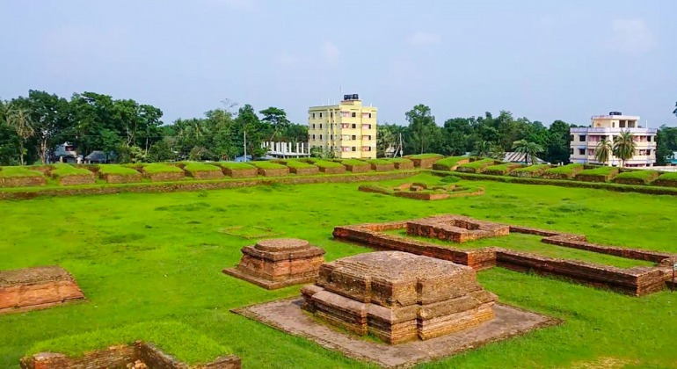**Historical Background:**

* **Buddhist Heritage:** Ananda Vihara is believed to have been constructed during the **Pala Dynasty**, which was known for its support of Buddhism and its role in promoting Buddhist education and culture across Bengal.
* **Educational and Spiritual Center:** Like other viharas (monasteries) in the region, Ananda Vihara functioned as a residence for monks and a place for scholarly activities. It played a vital role in the dissemination of Mahayana Buddhism and the study of Buddhist texts.

**Architectural Features:**

1. **Layout and Structure:**
   * The monastery complex is characterized by a large rectangular layout, which is typical of Buddhist monastic architecture of the period.
   * Ananda Vihara consists of several monk cells surrounding a central courtyard, where religious activities and gatherings would take place.
2. **Main Shrine:**
   * At the center of the complex is the main shrine, which would have housed a significant statue or image of **Buddha**. This shrine served as a focal point for worship and meditation.
   * The shrine’s design reflects the architectural style prevalent in ancient Bengal, characterized by brick construction and intricate decorations.
3. **Stupas:**
   * Ananda Vihara contains several stupas, which were built as religious monuments to house sacred relics associated with the Buddha or important Buddhist figures. These stupas often served as pilgrimage sites for devout Buddhists.
4. **Terracotta Plaques and Sculptures:**
   * The site features numerous terracotta plaques and sculptures, which depict scenes from the life of the Buddha, various Buddhist symbols, and motifs related to nature and daily life. These decorative elements showcase the artistic skills of the period and are significant examples of ancient Bengal’s craftsmanship.

**Archaeological Significance:**

* **Excavation Findings:** Archaeological excavations at Ananda Vihara have uncovered numerous artifacts, including pottery, coins, inscriptions, and various religious objects. These findings provide valuable insights into the monastic life of the time and the cultural practices of the Buddhist community.
* **Connections to Other Sites:** Ananda Vihara is part of the larger **Mainamati-Lalmai** archaeological complex, which includes several other significant Buddhist sites, such as **Shalban Vihara**, **Bhoj Vihara**, and **Itakhola Mura**. This interconnectedness highlights the region's importance as a center for Buddhist learning and practice.

**Cultural Importance:**

* **Role in Buddhism:** Ananda Vihara, along with other viharas in the area, contributed to the spread of Buddhism in Bengal. It served as a hub for the study and practice of Buddhist teachings, influencing the spiritual and cultural landscape of the region.
* **Artistic Contributions:** The terracotta art and sculptures found at Ananda Vihara are essential for understanding the artistic developments during the Pala period. These works reflect the religious devotion and craftsmanship of the time.

**Visitor Experience:**

* **Tourism:** Today, Ananda Vihara is a significant archaeological site for tourists, historians, and researchers. Visitors can explore the ruins of the monastery, appreciate the architectural design, and view the artifacts that have been discovered through excavation.
* **Connection to Mainamati Museum:** Many of the artifacts from Ananda Vihara are displayed in the nearby **Mainamati Museum**, which houses a collection of items from various archaeological sites in the region. The museum enhances the visitor experience by providing context and deeper insights into the history of Buddhism in Bengal.

**Conclusion:**

**Ananda Vihara** stands as a vital part of the Buddhist heritage in Bangladesh. Its ruins reflect the architectural, artistic, and spiritual achievements of the time, offering a window into the monastic life of ancient Bengal. As part of the Mainamati-Lalmai archaeological complex, Ananda Vihara continues to be an essential site for understanding the historical significance of Buddhism in the region.

**Bhoj Vihara**

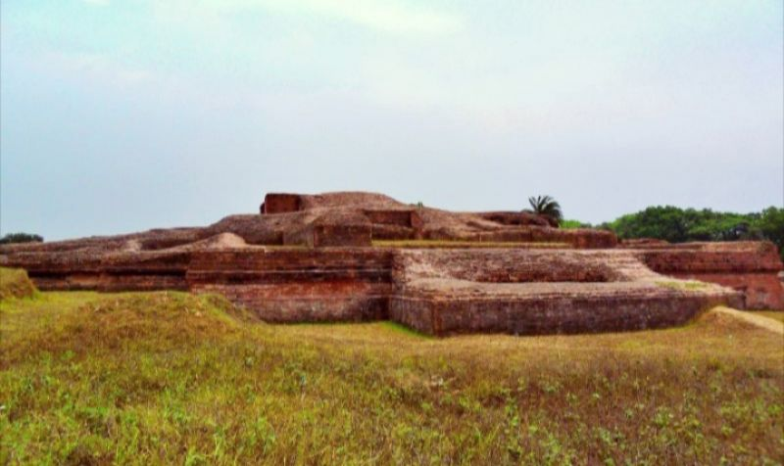**Bhoj Vihara** is an important archaeological site located in the **Mainamati-Lalmai** hill range near Cumilla, Bangladesh. This ancient Buddhist monastery is part of the region's rich Buddhist heritage, dating back to the early medieval period, primarily between the 7th and 12th centuries AD. Like other monasteries in the area, Bhoj Vihara played a significant role in the religious and educational life of the time.

**Historical Background:**

* **Buddhist Significance:** Bhoj Vihara is believed to have been established during the rule of the **Pala Dynasty**, known for its patronage of Buddhism and the promotion of Buddhist scholarship in Bengal.
* **Purpose:** The vihara served as a residential monastery for monks and a center for Buddhist learning. It provided a space for meditation, study of Buddhist texts, and communal living for the monastic community.

**Architectural Features:**

1. **Layout and Structure:**
   * Bhoj Vihara features a rectangular layout, typical of Buddhist monastic architecture of the period. The complex includes monk cells, a central courtyard, and various religious structures.
   * The layout is designed to facilitate communal living and religious practices, with monk cells arranged around a central area for gatherings and rituals.
2. **Main Shrine:**
   * At the center of Bhoj Vihara is the main shrine, which likely housed a significant statue of **Gautama Buddha** or other important Buddhist figures. This shrine would have been the focal point for worship and meditation.
3. **Stupas and Votive Structures:**
   * The site contains several stupas, which were constructed as religious monuments to house sacred relics. These stupas served as pilgrimage sites for devotees and were important for the monastic community's spiritual practices.
4. **Terracotta Decorations:**
   * Bhoj Vihara is known for its rich terracotta decorations, which include plaques and sculptures depicting various scenes from the life of Buddha, floral motifs, and symbolic representations associated with Buddhism.
   * The terracotta art reflects the high level of craftsmanship of the period and provides insights into the artistic styles prevalent in ancient Bengal.

**Archaeological Significance:**

* **Excavation Findings:** Excavations at Bhoj Vihara have unearthed numerous artifacts, including pottery, coins, and various religious objects. These findings contribute to our understanding of the monastic life, religious practices, and daily activities of the monks who lived there.
* **Connections to Other Sites:** Bhoj Vihara is part of the greater **Mainamati-Lalmai archaeological complex**, which includes other significant Buddhist sites such as **Shalban Vihara** and **Ananda Vihara**. This interconnectedness highlights the region's importance as a center of Buddhist learning and culture.

**Cultural Importance:**

* **Role in Buddhism:** Bhoj Vihara was integral to the spread of Mahayana Buddhism in Bengal. The monastery served as a hub for the study and practice of Buddhist teachings, influencing the spiritual and cultural landscape of the region.
* **Artistic Contributions:** The terracotta art and sculptures found at Bhoj Vihara are significant for understanding the artistic developments during the Pala period. These works reflect the religious devotion and craftsmanship of the time.

**Visitor Experience:**

* **Tourism:** Bhoj Vihara is a notable destination for tourists, historians, and researchers interested in ancient Buddhist sites. Visitors can explore the ruins, appreciate the architectural design, and learn about the historical significance of the vihara.
* **Connection to Mainamati Museum:** Artifacts from Bhoj Vihara, along with those from other sites in the region, are displayed at the nearby **Mainamati Museum**. The museum enhances the visitor experience by providing context and deeper insights into the history of Buddhism in Bengal.

**Conclusion:**

**Bhoj Vihara** stands as a testament to the rich Buddhist heritage of Bengal. Its well-preserved ruins, along with its terracotta decorations and archaeological findings, provide a unique glimpse into the monastic life, religious practices, and artistic achievements of ancient Bengal. As part of the Mainamati-Lalmai archaeological complex, Bhoj Vihara continues to be a vital site for understanding the historical significance of Buddhism in the region.

**Rupban Mura**

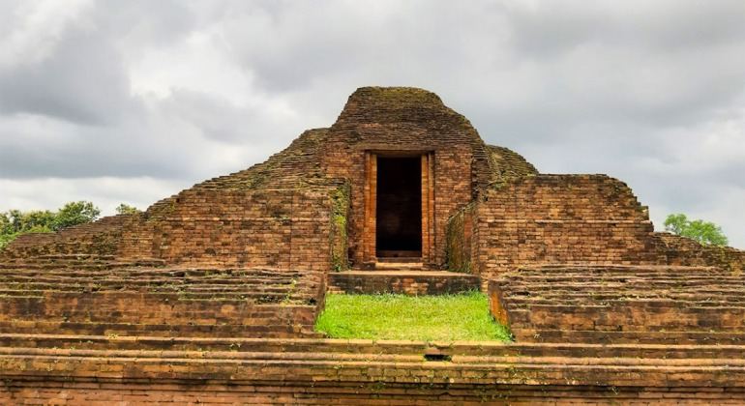**Rupban Mura** is an important archaeological site located in the **Mainamati-Lalmai** hill range in the Cumilla district of Bangladesh. This ancient Buddhist stupa complex is known for its historical and cultural significance, dating back to the early medieval period, particularly between the 7th and 12th centuries AD. Rupban Mura is one of several notable Buddhist sites in the region, which collectively highlight the rich heritage of Buddhism in Bengal.

**Historical Background:**

* **Buddhist Heritage:** Rupban Mura was constructed during a time when Buddhism thrived in Bengal, particularly under the patronage of the **Pala Dynasty**. This dynasty was instrumental in promoting Buddhism and establishing monasteries and stupas throughout the region.
* **Purpose:** The site served as a religious complex that housed stupas and possibly other structures related to monastic life and worship. Stupas were built as monuments to enshrine sacred relics and served as important pilgrimage sites for Buddhist devotees.

**Architectural Features:**

1. **Stupas:**
   * Rupban Mura is characterized by its well-preserved stupas, which were constructed to house relics of the Buddha or other significant Buddhist figures. Stupas are key elements of Buddhist architecture and symbolize enlightenment.
   * The stupas at Rupban Mura are significant for their size and design, reflecting the architectural style of the period. They often feature domed structures with a square base and a circular top, adorned with decorative elements.
2. **Terracotta Decorations:**
   * The site is known for its rich terracotta decorations, including plaques and sculptures that depict various scenes from Buddhist iconography. These decorations showcase the artistic craftsmanship of the time and provide insight into the cultural practices of the Buddhist community.
3. **Monastic Cells:**
   * Although primarily known for its stupas, Rupban Mura may have also included monastic cells or other structures used for meditation and communal living by the monks who resided there. These cells would have provided a space for spiritual practice and study.

**Archaeological Significance:**

* **Excavation Findings:** Archaeological excavations at Rupban Mura have uncovered a wealth of artifacts, including pottery, coins, and religious objects. These findings contribute to a better understanding of the monastic life, religious practices, and daily activities of the monks associated with the site.
* **Connections to Other Sites:** Rupban Mura is part of the larger **Mainamati-Lalmai** archaeological complex, which includes other significant Buddhist sites such as **Shalban Vihara**, **Ananda Vihara**, and **Bhoj Vihara**. This interconnectedness highlights the region's importance as a center for Buddhist learning and cultural exchange.

**Cultural Importance:**

* **Role in Buddhism:** Rupban Mura was an integral part of the Buddhist landscape in Bengal, contributing to the spread of Mahayana Buddhism and serving as a hub for religious activities. The site would have attracted monks and devotees from the surrounding regions, fostering a vibrant monastic community.
* **Artistic Contributions:** The terracotta art and architectural features found at Rupban Mura are significant for understanding the artistic developments during the Pala period. These works reflect the religious devotion and craftsmanship of the time.

**Visitor Experience:**

* **Tourism:** Rupban Mura is a notable destination for tourists, historians, and researchers interested in ancient Buddhist sites. Visitors can explore the ruins of the stupas, appreciate the architectural design, and learn about the historical significance of the complex.
* **Connection to Mainamati Museum:** Artifacts from Rupban Mura, along with those from other sites in the region, are displayed at the nearby **Mainamati Museum**. The museum enhances the visitor experience by providing context and deeper insights into the history of Buddhism in Bengal.

**Conclusion:**

**Rupban Mura** stands as a testament to the rich Buddhist heritage of Bengal. Its stupas, terracotta decorations, and archaeological findings provide a unique glimpse into the religious practices and artistic achievements of ancient Bengal. As part of the Mainamati-Lalmai archaeological complex, Rupban Mura continues to be a vital site for understanding the historical significance of Buddhism in the region.

**Itakhola Mura** is another significant archaeological site located in the **Mainamati-Lalmai** hill range in the Cumilla district of Bangladesh. This ancient Buddhist monastery complex dates back to the early medieval period, primarily between the 7th and 12th centuries AD, and is known for its historical and cultural significance in the region.

**Historical Background:**

* **Buddhist Heritage:** Itakhola Mura was constructed during a period when Buddhism flourished in Bengal, particularly under the patronage of the **Pala Dynasty**. This dynasty played a crucial role in promoting Buddhism and establishing various monasteries and stupas throughout the region.
* **Purpose:** The site served as a Buddhist monastery (vihara) where monks lived, studied, and practiced their faith. It was a center for Buddhist learning and spiritual activities, attracting scholars and devotees from the surrounding areas.

**Architectural Features:**

1. **Monastic Complex:**
   * Itakhola Mura features a rectangular layout typical of Buddhist monasteries. The complex includes several monk cells arranged around a central courtyard.
   * The layout is designed to facilitate communal living and spiritual practices, with the monk cells providing individual spaces for meditation and study.
2. **Main Shrine:**
   * At the center of the complex is the main shrine, which likely housed a significant statue or image of **Gautama Buddha** or other important Buddhist figures. This shrine served as the focal point for worship and meditation.
3. **Stupas:**
   * The site includes several stupas, which were built as religious monuments to enshrine sacred relics. These stupas served as important pilgrimage sites for devotees and played a significant role in the spiritual practices of the monastic community.
4. **Terracotta Decorations:**
   * Itakhola Mura is known for its intricate terracotta decorations, including plaques and sculptures that depict various scenes from the life of the Buddha, Buddhist symbols, and motifs related to nature. The terracotta art reflects the high level of craftsmanship of the period and provides insights into the cultural practices of the time.

**Archaeological Significance:**

* **Excavation Findings:** Archaeological excavations at Itakhola Mura have uncovered a wealth of artifacts, including pottery, coins, and religious objects. These findings contribute to a better understanding of the monastic life, religious practices, and daily activities of the monks associated with the site.
* **Connections to Other Sites:** Itakhola Mura is part of the greater **Mainamati-Lalmai** archaeological complex, which includes other significant Buddhist sites such as **Shalban Vihara**, **Ananda Vihara**, and **Bhoj Vihara**. This interconnectedness highlights the region's importance as a center of Buddhist learning and culture.

**Cultural Importance:**

* **Role in Buddhism:** Itakhola Mura was integral to the spread of Mahayana Buddhism in Bengal. The monastery served as a hub for the study and practice of Buddhist teachings, influencing the spiritual and cultural landscape of the region.
* **Artistic Contributions:** The terracotta art and architectural features found at Itakhola Mura are significant for understanding the artistic developments during the Pala period. These works reflect the religious devotion and craftsmanship of the time.

**Visitor Experience:**

* **Tourism:** Itakhola Mura is a notable destination for tourists, historians, and researchers interested in ancient Buddhist sites. Visitors can explore the ruins, appreciate the architectural design, and learn about the historical significance of the vihara.
* **Connection to Mainamati Museum:** Artifacts from Itakhola Mura, along with those from other sites in the region, are displayed at the nearby **Mainamati Museum**. The museum enhances the visitor experience by providing context and deeper insights into the history of Buddhism in Bengal.

**Conclusion:**

**Itakhola Mura** is a testament to the rich Buddhist heritage of Bengal. Its well-preserved ruins, terracotta decorations, and archaeological findings provide a unique glimpse into the religious practices and artistic achievements of ancient Bengal. As part of the Mainamati-Lalmai archaeological complex, Itakhola Mura continues to be a vital site for understanding the historical significance of Buddhism in the region.

**Conclusion of Maynamati:**

Maynamati stands as a significant testament to the rich Buddhist heritage of Bengal, reflecting centuries of spiritual and cultural evolution. As an archaeological site, it offers invaluable insights into the monastic life, architectural innovations, and artistic achievements of ancient Buddhist communities. The presence of various viharas, stupas, and terracotta art across the landscape highlights the area’s importance as a center of learning and devotion during the Pala Dynasty.

The exploration of Maynamati not only deepens our understanding of the historical spread of Buddhism in the region but also underscores the interconnectedness of cultural practices across time and space. The intricate designs and structures found at sites like **Shalban Vihara**, **Ananda Vihara**, **Bhoj Vihara**, **Itakhola Mura**, and **Rupban Mura** illustrate the skill and dedication of those who contributed to the Buddhist monastic tradition.

Moreover, Maynamati continues to play a crucial role in contemporary discussions about heritage preservation, tourism, and cultural identity in Bangladesh. The ongoing archaeological efforts and the establishment of the **Mainamati Museum** serve not only to protect this invaluable history but also to educate future generations about the rich tapestry of Buddhist heritage that Maynamati embodies.

In summary, Maynamati is not merely a collection of ruins; it is a vital link to the past that invites us to reflect on the spiritual and cultural legacies that shape our present and future. By honoring and studying this heritage, we gain a deeper appreciation for the historical significance of Buddhism in Bengal and its enduring impact on the region's cultural landscape.